DOCAYA
Electronic Document Management System
Functional & Technical Specification
Built on Microsoft Azure · SharePoint Online · Entra ID
Version 1.0.0
Status: Draft for Review · Classification: Internal

Table of Contents

Document Control
Attribute | Detail
Document Title | Docaya EDMS — Functional & Technical Specification
Version | 1.0.0
Reviewers | Solution Architect, Security Officer, Compliance, SharePoint Lead
Approval | Program Sponsor / Steering Committee
Status | Draft for Review
Classification | Internal
Platform | Microsoft Azure, SharePoint Online, Microsoft Entra ID

Revision History
Version | Date | Author | Summary of Change
0.1 | Draft |  | Initial skeleton & architecture
1.0 | Current |  | Complete functional & technical baseline

1. Introduction

1.1 Purpose
This document defines the complete functional and technical specification for Docaya, an enterprise Electronic Document Management System (EDMS). It is the authoritative reference for the design, build, testing, and deployment teams. Every requirement uses RFC-2119 keywords (MUST, SHOULD, MAY) to indicate obligation level.

1.2 Scope
Docaya sits as a governance and intelligence layer on top of an existing SharePoint Online environment. It introduces a controlled capture-classify-approve-promote pipeline so that no document reaches the official document library until it has been enriched with metadata and formally approved. In scope:
- Document capture into a controlled Staging Zone with a temporary tracking number.
- A metadata-driven classification step (class, sensitivity, priority, department, access).
- A configurable approval workflow that promotes approved documents into SharePoint Online.
- Native versioning upon promotion and on subsequent edits.
- A real-time Notification Center, including document expiry reminders.
- Access management using Microsoft Entra ID single sign-on (RBAC + ABAC + SharePoint ACL).
- An Admin Center for configuration and a User Management module.
- All metadata, links, workflow state, and audit stored in Azure SQL Database.

1.3 Out of Scope
- Migration of legacy documents already resident in SharePoint (handled by a separate migration workstream).
- Replacement of SharePoint Online as the underlying content store — it remains the system of record.
- Physical records / paper archiving processes beyond scan-to-Docaya capture.

1.4 Definitions & Acronyms
Term | Meaning
EDMS | Electronic Document Management System
Staging Zone | Temporary, controlled holding area for documents before approval
Promotion | Act of moving an approved document from staging into the live SharePoint library
Tracking Number | Temporary identifier (e.g., DOC-2026-00123) assigned at capture
RBAC / ABAC | Role- / Attribute-Based Access Control
Entra ID | Microsoft Entra ID (formerly Azure Active Directory)
OBO | On-Behalf-Of OAuth flow (API acts as the signed-in user)
SoR | System of Record (SharePoint Online)
SLA | Service Level Agreement

2. Business Context & Objectives

2.1 Problem Statement
Documents today are uploaded directly into SharePoint with inconsistent metadata, no enforced classification, and no approval gate. This leads to poor findability, weak governance, uncontrolled sensitive-document exposure, and no proactive expiry management. Docaya solves this by enforcing a governed pipeline while preserving all existing SharePoint investment.

2.2 Objectives
# | Objective | Success Measure
O1 | Enforce classification & approval before publishing | 100% of new documents pass through the pipeline
O2 | Improve findability | Median time-to-find < 3 seconds
O3 | Proactive lifecycle management | Zero documents expire without prior notification
O4 | Strong, auditable access control | Every access decision logged & attributable
O5 | Single Microsoft ecosystem | One identity (Entra ID), one platform (Azure + M365)

2.3 Personas
Persona | Role | Primary Needs
Contributor | Uploads documents | Fast capture, guided metadata
Approver | Reviews & approves | Clear queue, one-click approve/reject
Compliance Officer | Governance | Retention, legal hold, audit visibility
Administrator | Configures system | Self-serve config, no code
Viewer / Consumer | Finds & reads | Powerful search, secure access

3. Solution Overview
Docaya is a multi-tier application built entirely within the Microsoft ecosystem. A React + Fluent UI single-page application provides the experience; an ASP.NET Core API and Azure Functions provide the logic; Durable Functions orchestrate the approval workflow; SharePoint Online stores the approved binaries; and Azure SQL stores all metadata, permissions, workflow state, and audit records.

3.1 Guiding Principles
- SharePoint remains the system of record — no lock-in, native versioning preserved.
- Staging-first — nothing is published without classification and approval.
- Secure by default — Entra ID SSO, least privilege, everything audited.
- Configuration over code — admins self-serve via the Admin Center.
- Event-driven — every state change emits an event for loose coupling and audit.

4. High-Level Architecture
The following diagram shows the end-to-end platform architecture, organized into layers from users at the top down to the Microsoft 365 tenant. The highlighted orange path represents the distinctive staging-first promotion flow.
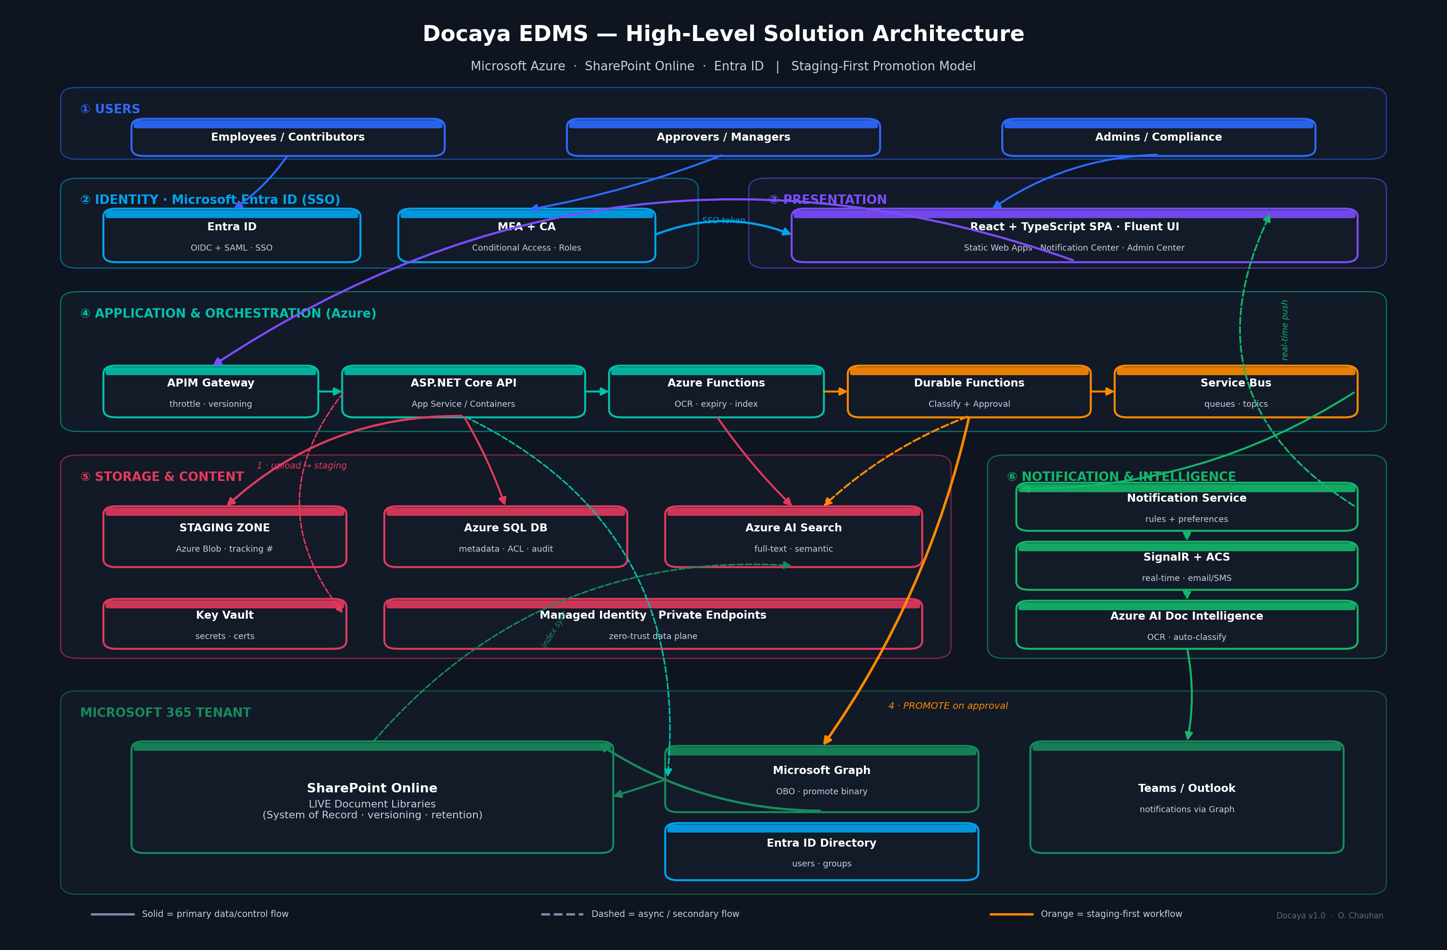
Figure 1 — Docaya High-Level Solution Architecture (platform view)

4.1 Architecture Layers
Layer | Responsibility | Key Azure / M365 Services
Users | Human actors | Browser / Teams client
Identity | Authentication & SSO | Microsoft Entra ID, MFA, Conditional Access
Presentation | User experience | React + Fluent UI on Azure Static Web Apps
Application | Business logic & APIs | APIM, ASP.NET Core, Azure Functions
Orchestration | Workflow & messaging | Durable Functions, Service Bus
Storage | Content & metadata | SharePoint Online, Blob (staging), Azure SQL, AI Search
Notification | Alerts & intelligence | SignalR, Communication Services, AI Doc Intelligence

4.2 Application (Component) Architecture
The component view below decomposes the application into domain modules and shows the synchronous and asynchronous flows between them.
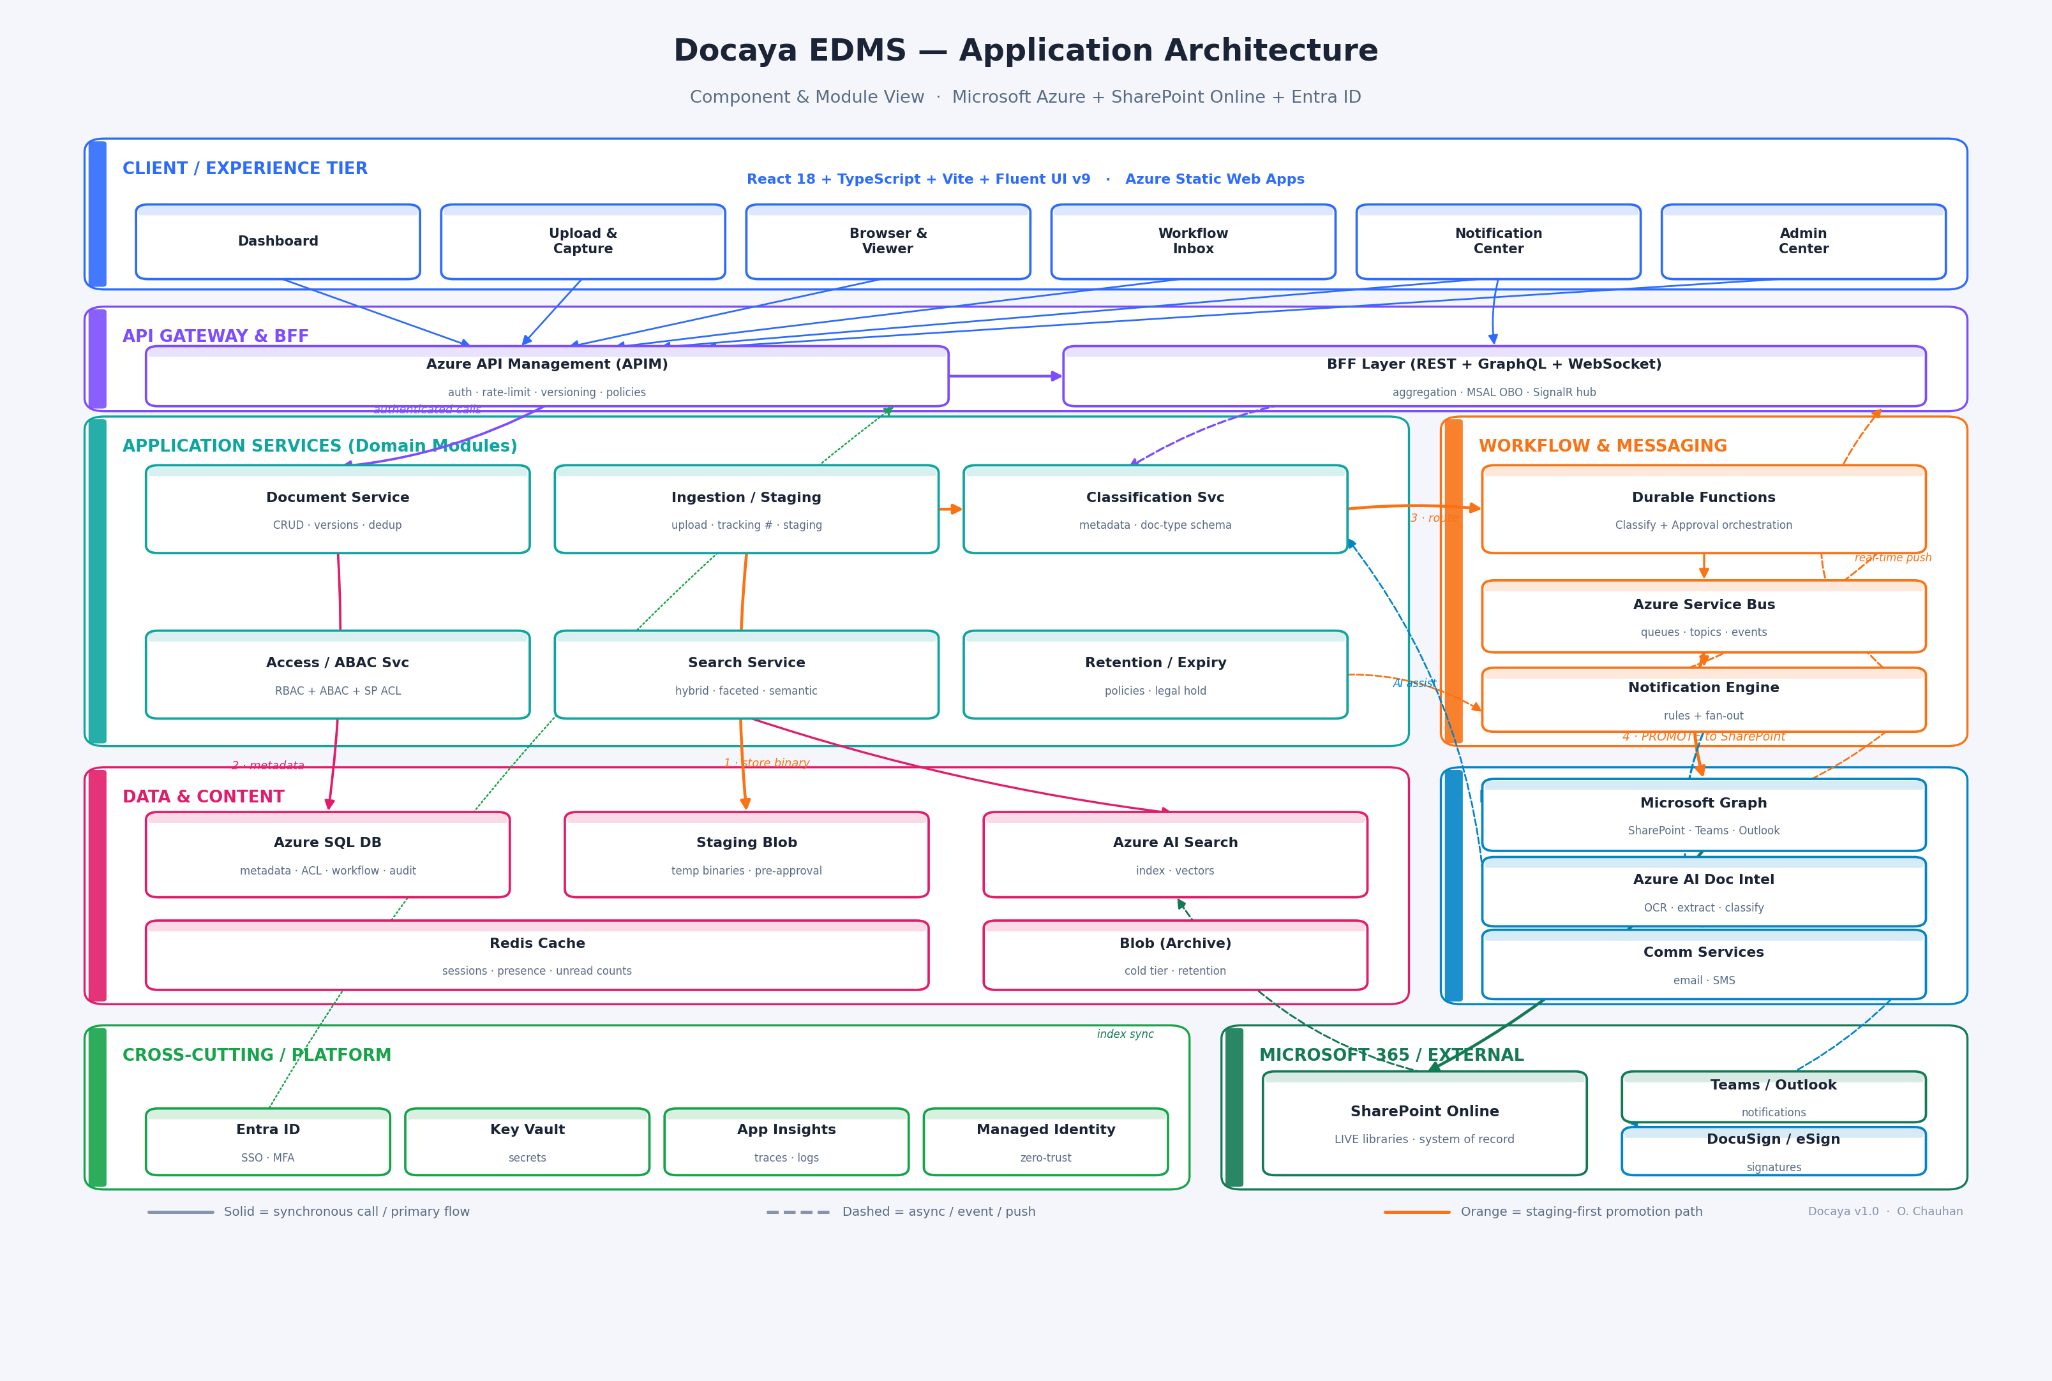
Figure 2 — Docaya Application Architecture (component & module view)

5. Functional Requirements

5.1 Document Capture & Ingestion
ID | Requirement | Priority
FR-CAP-01 | The system MUST allow drag-and-drop upload of single and multiple files. | Must
FR-CAP-02 | The system MUST support resumable uploads for large files (up to 5 GB). | Must
FR-CAP-03 | On upload the system MUST store the binary in the Staging Zone (not SharePoint). | Must
FR-CAP-04 | The system MUST assign a unique tracking number (DOC-YYYY-NNNNN) at capture. | Must
FR-CAP-05 | The system SHOULD support email-in capture to a per-folder address. | Should
FR-CAP-06 | The system SHOULD support mobile scan-to-PDF capture. | Should
FR-CAP-07 | The system MAY auto-detect duplicates via content hash. | May

5.2 Classification & Metadata
ID | Requirement | Priority
FR-CLS-01 | The system MUST prompt for classification, sensitivity, priority, department and access on capture. | Must
FR-CLS-02 | Metadata fields MUST be validated against a configurable document-type schema. | Must
FR-CLS-03 | The system SHOULD auto-suggest classification and metadata using Azure AI Document Intelligence. | Should
FR-CLS-04 | The system MUST record the target SharePoint library derived from classification rules. | Must
FR-CLS-05 | Sensitivity MUST support at least: Public, Internal, Confidential, Restricted. | Must

5.3 Workflow & Approval
ID | Requirement | Priority
FR-WF-01 | The system MUST route documents for approval based on classification and sensitivity. | Must
FR-WF-02 | The system MUST support single, sequential, and parallel approver configurations. | Must
FR-WF-03 | The document MUST remain in staging with status PendingApproval until approved. | Must
FR-WF-04 | On approval the system MUST promote the binary to the target SharePoint library. | Must
FR-WF-05 | On promotion the system MUST capture the SharePoint Item ID and set version 1.0. | Must
FR-WF-06 | On rejection the document MUST return to the contributor with comments. | Must
FR-WF-07 | Each approval task MUST have an SLA timer with escalation on breach. | Should
FR-WF-08 | Approvers SHOULD be able to approve directly from email / Teams / Notification Center. | Should

5.4 Versioning & Records
ID | Requirement | Priority
FR-VER-01 | Every edit after publication MUST create a new SharePoint version (2.0, 3.0…). | Must
FR-VER-02 | Version history MUST be viewable and restorable from Docaya. | Must
FR-VER-03 | The system SHOULD support check-out / check-in locking. | Should
FR-VER-04 | The system MUST support records declaration (freeze) for compliance. | Should

5.5 Search & Retrieval
ID | Requirement | Priority
FR-SR-01 | The system MUST provide full-text and metadata search via Azure AI Search. | Must
FR-SR-02 | Search MUST honor the user's effective permissions (no unauthorized results). | Must
FR-SR-03 | The system SHOULD provide faceted filters (type, owner, date, tag, department). | Should
FR-SR-04 | The system SHOULD provide semantic 'Ask Docaya' Q&A grounded in permitted documents. | Should

5.6 Notification Center
ID | Requirement | Priority
FR-NT-01 | The system MUST provide an in-app Notification Center with real-time updates. | Must
FR-NT-02 | The system MUST notify on approval requests, decisions, mentions, and shares. | Must
FR-NT-03 | The system MUST notify document owners of upcoming expiry at T-30, T-7, and T-1 days. | Must
FR-NT-04 | Users MUST be able to configure channel preferences per notification type. | Must
FR-NT-05 | Security notifications MUST be mandatory and non-disable-able. | Must
FR-NT-06 | The system SHOULD deliver via email (ACS) and Teams/Outlook (Graph). | Should

5.7 Access Management
ID | Requirement | Priority
FR-AC-01 | Authentication MUST use Microsoft Entra ID single sign-on. | Must
FR-AC-02 | The system MUST enforce RBAC via Entra app roles. | Must
FR-AC-03 | The system MUST enforce ABAC rules based on department and sensitivity. | Must
FR-AC-04 | Document access MUST ultimately honor SharePoint permissions via OBO. | Must
FR-AC-05 | Sensitive actions MUST trigger step-up MFA. | Should

5.8 Admin Center
ID | Requirement | Priority
FR-ADM-01 | Admins MUST manage document types and metadata schemas without code. | Must
FR-ADM-02 | Admins MUST design and version approval workflows visually. | Must
FR-ADM-03 | Admins MUST manage retention policies and legal holds. | Must
FR-ADM-04 | Admins MUST edit notification templates and default channel policies. | Must
FR-ADM-05 | Admins MUST view system health, usage, and audit logs. | Must

5.9 User Management
ID | Requirement | Priority
FR-UM-01 | Users MUST be provisioned from Entra ID (SCIM / JIT). | Must
FR-UM-02 | Admins MUST assign roles and group memberships. | Must
FR-UM-03 | The system MUST support user suspension and secure offboarding. | Must
FR-UM-04 | Offboarding MUST reassign document ownership and preserve the audit trail. | Must

6. Document Lifecycle & Workflow

6.1 Status Lifecycle
A document transitions through the following states. The binary lives in the Staging Zone until the Approved → Published transition, at which point it is promoted into SharePoint Online.
State | Meaning | Binary Location
Staged | Uploaded, tracking number assigned | Staging Blob
Classified | Metadata captured | Staging Blob
PendingApproval | Awaiting approver decision | Staging Blob
Approved | Approver signed off | Staging Blob (transient)
Published | Promoted to SharePoint, version 1.0 | SharePoint Online
Superseded | Replaced by a newer approved version | SharePoint Online
Expiring | Within expiry notification window | SharePoint Online
Archived | Retention reached, moved to cold tier | Archive Blob

6.2 End-to-End Promotion Flow

fd

6.3 Routing Rules (example)
Condition | Route To | Notes
Sensitivity = Restricted | Compliance + Dept Head | Two-level, sequential
Classification = Contract AND Value > 100k | Legal → CFO | Escalated approval
Sensitivity = Internal | Line Manager | Single approver
Sensitivity = Public | Auto-approve | No manual gate

7. Notification Center Design
The Notification Center is a first-class surface. A daily timer-triggered Azure Function scans document expiry dates and raises reminders; domain events (approvals, mentions, shares, security) flow through Service Bus into the Notification Engine, which applies user preferences and fans out across channels.

7.1 Notification Categories
Category | Examples | Default Channels
Workflow | Approval requested, approved, rejected, SLA breach | In-app, Email, Teams
Collaboration | Mention, comment, task assigned | In-app, Push
Document | Shared, new version, downloaded | In-app
Expiry | T-30 / T-7 / T-1 day reminders | In-app, Email
Security | New device, permission change, external share | In-app, Email, Push (locked)
System | Storage, license, maintenance | In-app, Email

7.2 Expiry Engine
- A timer-triggered Azure Function runs daily and queries Documents.ExpiryDate.
- Reminders fire at T-30, T-7 and T-1 days and on the expiry date.
- The Notification Center exposes an Expiry Dashboard: Expiring in 30 days · Expired · Pending Renewal · Under Legal Hold.
- Owners can renew (extend expiry) or route the document into a review workflow.

8. Technical Architecture

8.1 Technology Stack
Concern | Technology | Rationale
Frontend | React 18 + TypeScript + Vite + Fluent UI v9 | Native M365 look, performance, type-safety
Frontend hosting | Azure Static Web Apps | Global CDN, built-in auth & CI/CD
API gateway | Azure API Management | Throttling, versioning, policy enforcement
Backend API | ASP.NET Core 8 (App Service / Container Apps) | Robust, first-class Azure + Graph SDK
Event jobs | Azure Functions | OCR, expiry scan, index sync, cleanup
Workflow | Durable Functions / Logic Apps | Long-running approval orchestration
Messaging | Azure Service Bus | Reliable queues & topics
Real-time | Azure SignalR Service | Live notifications & presence
Live content | SharePoint Online (via Microsoft Graph) | System of record, native versioning
Staging | Azure Blob Storage (Hot) | Cheap transient holding
Metadata DB | Azure SQL Database | Metadata, ACL, workflow, audit
Search | Azure AI Search | Full-text + semantic + faceted
AI / OCR | Azure AI Document Intelligence + Azure OpenAI | Classification, extraction, summaries
Secrets | Azure Key Vault | Secrets, certs, keys
Observability | Application Insights + Azure Monitor | Traces, metrics, logs, alerts
IaC / CI-CD | Bicep + GitHub Actions / Azure DevOps | Reproducible provisioning & delivery

8.2 Security Architecture
- Authentication: Entra ID SSO via OIDC + PKCE for the SPA; MFA and Conditional Access enforced.
- Authorization: RBAC (Entra app roles) + ABAC (department/sensitivity rules) + SharePoint ACL via On-Behalf-Of.
- Encryption: TLS 1.3 in transit; AES-256 at rest; per-tenant keys with Key Vault (BYOK optional).
- Network: Private Endpoints for SQL, Blob, Key Vault; Front Door + WAF at the edge; Managed Identity between services.
- Audit: Immutable, hash-chained audit table in Azure SQL for tamper-evidence.
- Data protection: Malware scan on upload; DLP + PII detection; Microsoft Purview sensitivity labels.

8.3 Data Model (Azure SQL)
Azure SQL holds all metadata and the pointers into SharePoint. Key tables:
Table | Purpose | Key Columns
Documents | Central registry | TrackingNumber, Status, SharePointItemId, VersionLabel, ExpiryDate
DocumentAccess | ABAC / scoping | PrincipalId, PrincipalType, Permission
WorkflowInstances | Approval state & history | Stage, AssignedTo, Decision, ActedAt
Notifications | Durable notification history | UserId, Type, Channel, ReadAt
AuditLog | Tamper-evident audit | ActorId, Action, PrevHash, Hash
RetentionPolicy | Lifecycle rules | Trigger, Duration, Disposition

Core DDL — Documents table
- DocumentId UNIQUEIDENTIFIER PK
- TrackingNumber NVARCHAR(30) — e.g. DOC-2026-00123
- Title, Classification, Sensitivity, Priority, Department
- Status NVARCHAR(30) — Staged → PendingApproval → Approved → Published → Archived
- StagingBlobUrl NVARCHAR(1000) — transient location
- SharePointSiteId / SharePointItemId / SharePointWebUrl — set on promotion
- VersionLabel NVARCHAR(20) — 1.0, 2.0 …
- ExpiryDate DATE — drives the Notification Center
- CreatedBy / CreatedAt / ApprovedBy / ApprovedAt

8.4 SharePoint Integration (Microsoft Graph)
- The API accesses SharePoint as the signed-in user via the OAuth On-Behalf-Of flow, so SharePoint's native permissions are always honored.
- Promotion uploads the staged binary to the target library using Graph drive item APIs, returning the item ID and version.
- Versioning relies on SharePoint's native version history; Docaya records the version label in Azure SQL.
- Indexing: an Azure Function syncs SharePoint content into Azure AI Search for unified search.

8.5 API Design
APIs are versioned (/api/v1), documented with OpenAPI 3.1, secured with OAuth 2.0 bearer tokens, and use idempotency keys on writes. Representative endpoints:
Method & Path | Purpose
POST /api/v1/documents | Capture a document into staging
PATCH /api/v1/documents/{id} | Update metadata / classification
POST /api/v1/documents/{id}/submit | Submit for approval
POST /api/v1/workflows/{id}/decision | Approve / reject
GET /api/v1/documents/{id}/versions | Retrieve version history
POST /api/v1/search | Hybrid search with filters
GET /api/v1/notifications | List notifications (cursor paginated)
POST /api/v1/notifications/read | Bulk mark read

9. Non-Functional Requirements
Attribute | Target
Availability | 99.9% (99.95% enterprise tier)
Page load latency | p95 < 1.5 s
Search latency | p95 < 400 ms
Scale | 10,000+ concurrent users; 1B+ documents
Max file size | 5 GB (resumable, chunked)
Durability | 11 nines (object store replication)
RPO / RTO | RPO ≤ 5 min · RTO ≤ 1 hr
Backup | Continuous + daily snapshots, cross-region
Accessibility | WCAG 2.2 AA
Localization | English + Arabic (RTL) at launch

10. Deployment & DevOps
- Infrastructure as Code with Bicep provisions the full Azure resource group.
- CI/CD via GitHub Actions / Azure DevOps: build → test → security scan → deploy.
- Environments: local → dev → staging (prod-like) → production, each isolated.
- Deployment strategy: blue-green / canary with automatic rollback on SLO breach.
- Observability: OpenTelemetry traces, Application Insights dashboards, alerting.

10.1 VS Code Solution Structure
Path | Contents
/infra | Bicep modules (SQL, storage, App Service, APIM, Entra)
/src/frontend | React + TypeScript + Fluent UI SPA
/src/api | ASP.NET Core Web API (Domain, Application, Infrastructure)
/src/functions | Azure Functions (ExpiryScanner, OcrClassifier, SearchIndexer)
/src/workflow | Durable Functions (Classification, Approval)
/tests | Unit, integration, e2e (Playwright)
/.github/workflows | CI/CD pipelines

11. Testing Strategy
Layer | Tooling | Coverage
Unit | Vitest / xUnit | 80%+ core logic
Integration | Service + DB contract tests | All service boundaries
End-to-end | Playwright | Critical journeys (capture→publish)
Load | k6 | Search, upload, concurrency
Security | OWASP ZAP, Snyk, Trivy | SAST / DAST / SCA
Accessibility | axe-core + manual | WCAG 2.2 AA

12. Compliance & Governance
- Retention: time-based or event-based policies with auto-archive / review / delete dispositions.
- Legal hold: overrides retention, freezes documents, blocks deletion, fully audited.
- Data residency: tenant data pinned to a chosen Azure region.
- Frameworks: designed for GDPR / DPDP, ISO 27001, SOC 2, and 21 CFR Part 11 (e-sign).
- Right-to-be-forgotten: verifiable erasure workflow with certificate.

13. Risks & Mitigations
Risk | Impact | Mitigation
Graph API throttling during bulk promotion | Delayed publishing | Batching, retry with backoff, queue smoothing
Staging Zone growth | Cost | Lifecycle cleanup after promotion
Complex ABAC rules | Misconfiguration | Rule simulator + audit before publish
User adoption | Low usage | Fluent UI familiarity, training, phased rollout
SharePoint permission drift | Access errors | OBO honors SP ACL; periodic reconciliation

14. Delivery Roadmap
Phase | Scope | Timeline
MVP | Auth, capture→staging, classify, approval, promotion, versioning | Months 1–5
V1 | Notification Center, Admin Center, User Management, search | Months 5–8
V2 | AI (OCR, Ask Docaya), analytics, compliance, integrations | Months 9–12

15. Assumptions & Open Questions
# | Item | Owner
A1 | Existing SharePoint Online tenant is available and licensed | IT
A2 | Entra ID is the sole identity provider | Security
Q1 | Native e-signature vs. DocuSign integration for V1? | Product
Q2 | Default data residency region? | Compliance
Q3 | On-prem deployment option required? | Sales / Eng

— End of Document —

